**Artificial Intelligence**

**Digital Assignment - 1**

**Team Members :**

23BAI1010 – SASANK V

23BAI1054 – AKSHARA GATTUPALLI

23BAI1063 - CHAKKA SAI DHEERAJ

**Task 1 Requirements:**

1. **Implement and evaluate a basic CNN model:**
   * Preprocess the dataset (resizing, normalization, data augmentation).
   * Build a CNN architecture with 3-4 convolutional layers using Conv2D, MaxPooling, Flatten, and Dense layers.
   * Evaluate the model using metrics such as accuracy, F1-score, and AUC-ROC.
2. **Transfer Learning:**
   * Fine-tune pretrained CNN models (ResNet50, VGG16, or MobileNet).
3. **Optimize hyperparameters:**
   * Experiment with learning rates and batch sizes.

**Dataset Preparation**

**Preprocessing Steps:**

* **Resizing:** All images are resized to (224, 224) for compatibility with pretrained models and for uniformity in input dimensions.
* **Data Augmentation:** Applied transformations include:
  + Random horizontal flipping.
  + Random rotation up to 10 degrees.
  + Random affine transformations.
  + Color jitter (brightness and contrast adjustments).
* **Normalization:** Images are normalized with mean [0.485, 0.456, 0.406] and standard deviation [0.229, 0.224, 0.225].

**Basic CNN Architecture**

The basic CNN model consists of four convolutional blocks, followed by a fully connected classifier:

**Convolutional Layers:**

* **First Block:**
  + Conv2D with 32 filters, kernel size 3x3, ReLU activation.
  + Batch normalization and MaxPooling.
* **Second Block:**
  + Conv2D with 64 filters, kernel size 3x3, ReLU activation.
  + Batch normalization and MaxPooling.
* **Third Block:**
  + Conv2D with 128 filters, kernel size 3x3, ReLU activation.
  + Batch normalization and MaxPooling.
* **Fourth Block:**
  + Conv2D with 256 filters, kernel size 3x3, ReLU activation.
  + Batch normalization and MaxPooling.

**Classifier:**

* Flatten layer.
* Fully connected layer with 512 units and ReLU activation.
* Dropout (50%).
* Output layer with 2 units (softmax activation).

**Loss and Optimization:**

* **Loss Function:** CrossEntropyLoss.
* **Optimizer:** Adam with a learning rate of 0.001.
* **Scheduler:** ReduceLROnPlateau to adjust learning rate based on validation accuracy.

**Pretrained Models**

Transfer learning was performed using:

* **ResNet50:** Final fully connected layer modified to output 2 classes.
* **VGG16:** Final classifier layer modified to output 2 classes.
* **MobileNetV2:** Final classifier layer modified to output 2 classes.

**Model Training**

**Data Splitting:**

* The dataset was split into training and validation sets (80:20 ratio) with stratified sampling to maintain class balance.

**Training Details:**

* **Batch Size:** 32.
* **Number of Epochs:** 30.
* **Device:** CUDA (GPU) if available, else CPU.

**Metrics:**

* **Accuracy:** Measures overall classification performance.
* **F1-Score:** Evaluates the balance between precision and recall.
* **AUC-ROC:** Measures the model’s ability to distinguish between classes.

**Results and Visualization**

**Training and Validation Metrics:**

* Plots of loss, accuracy, and F1-score over epochs were saved.
* Confusion matrix visualization was generated to understand misclassifications.

**1.Basic CNN**

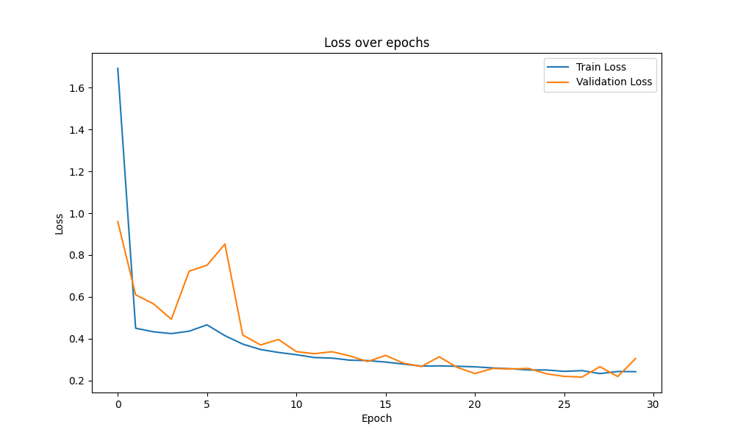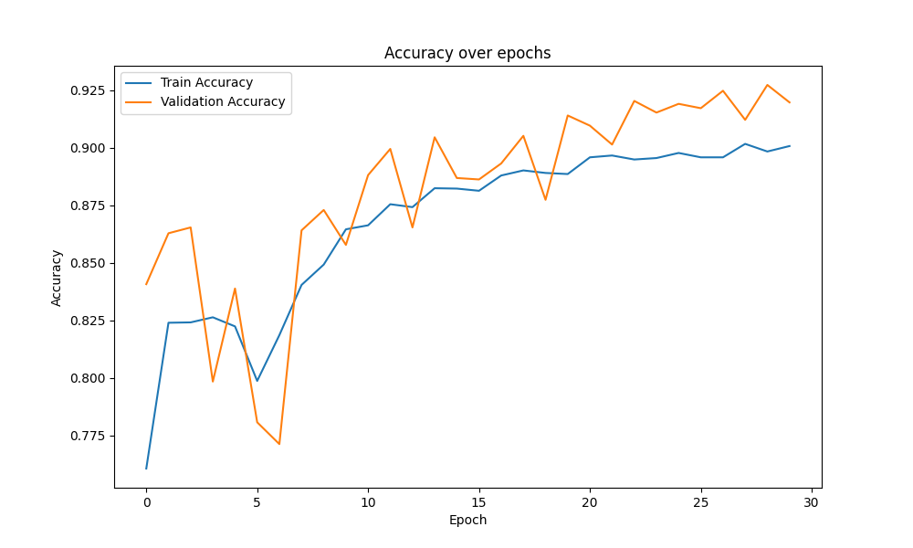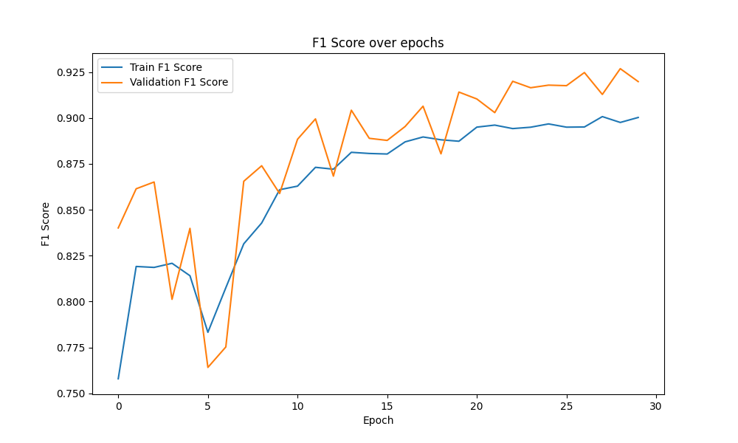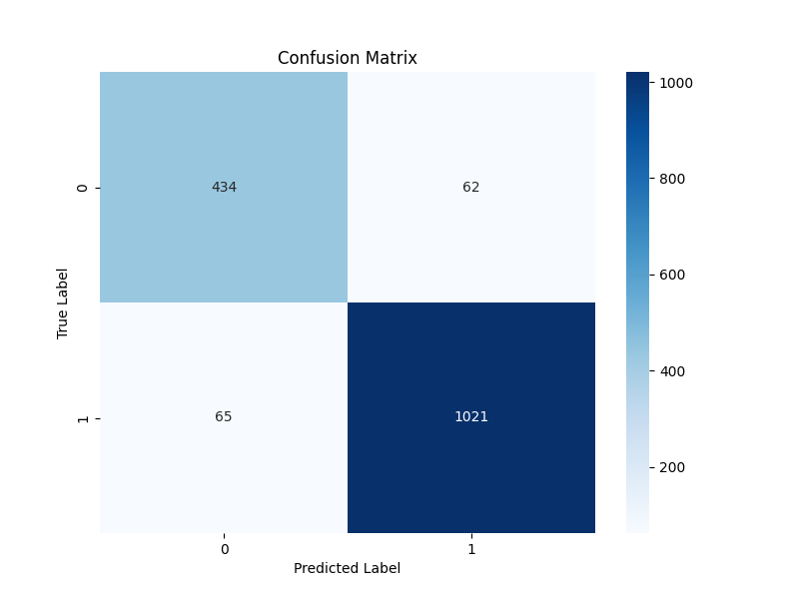

**2.ResNet50**

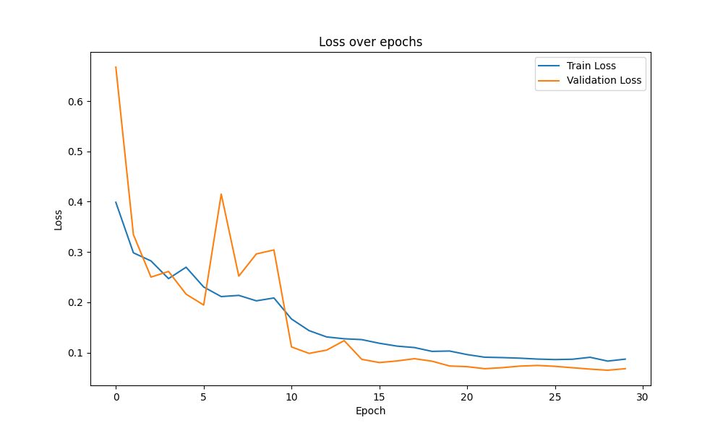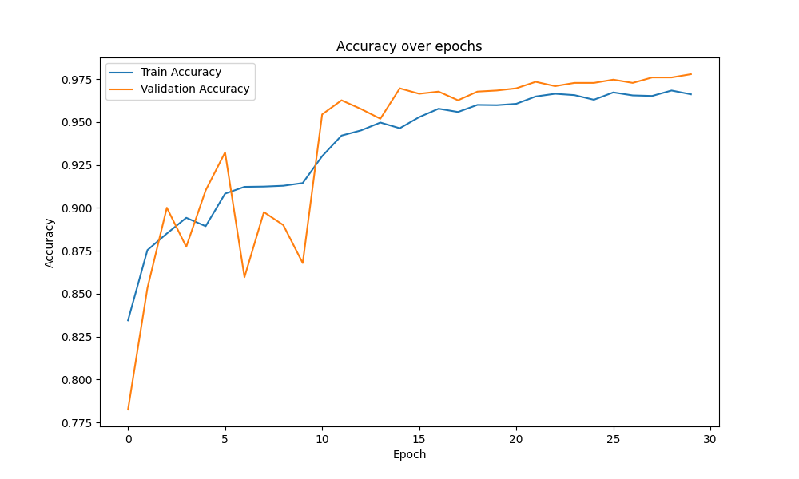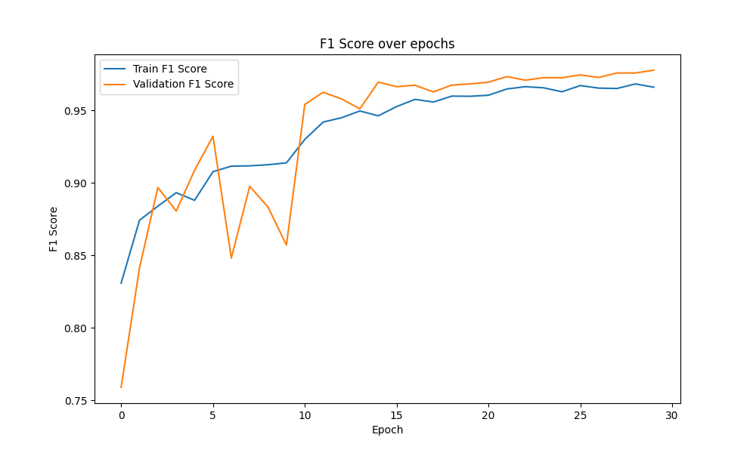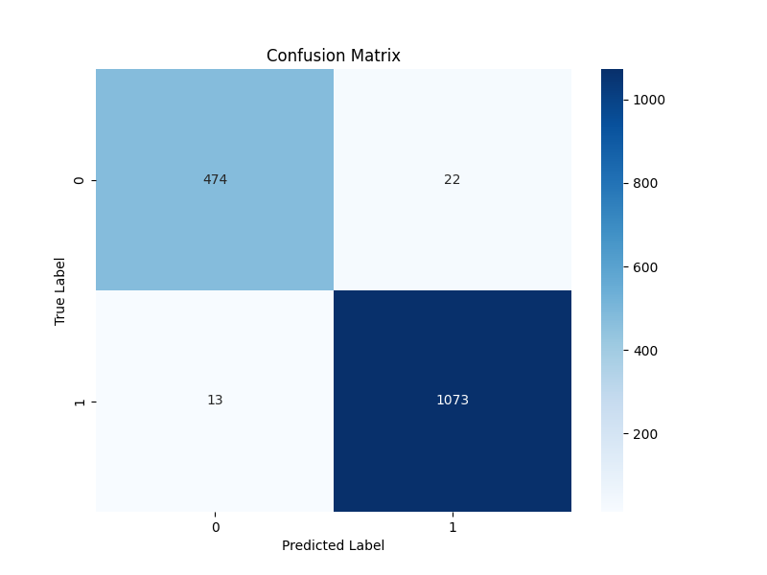

**3. VGG1**

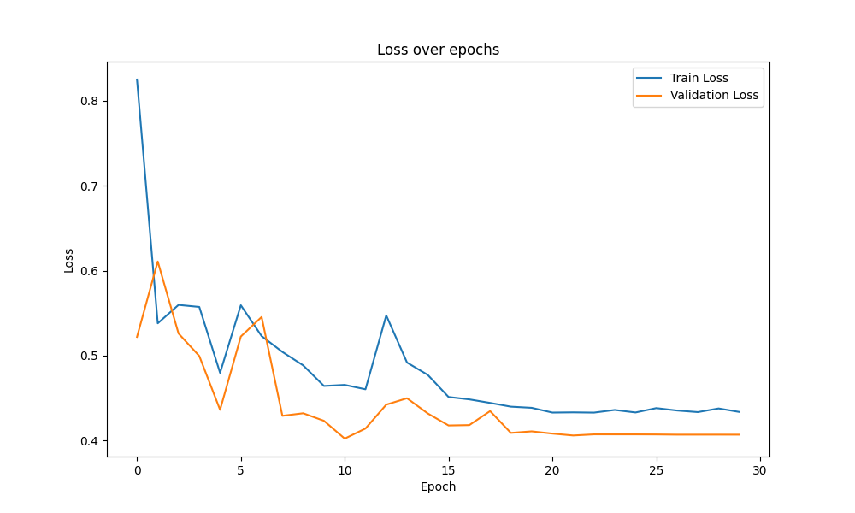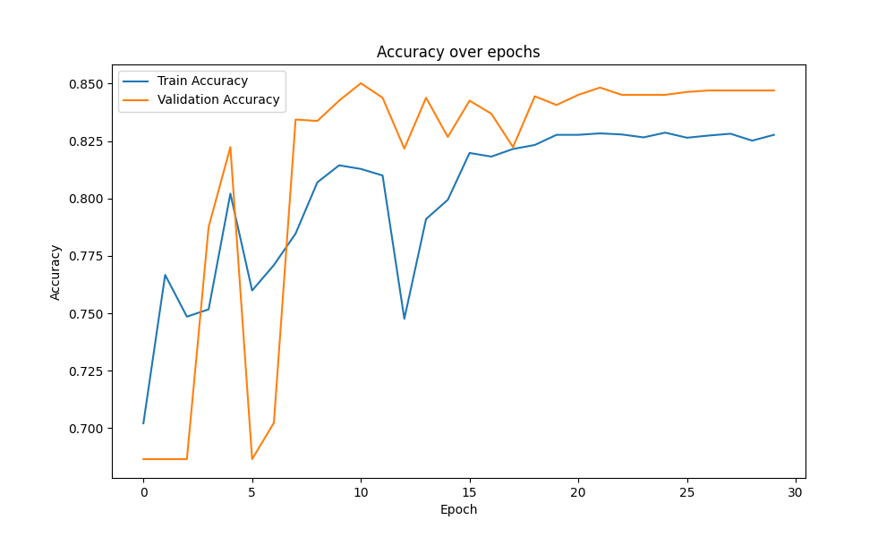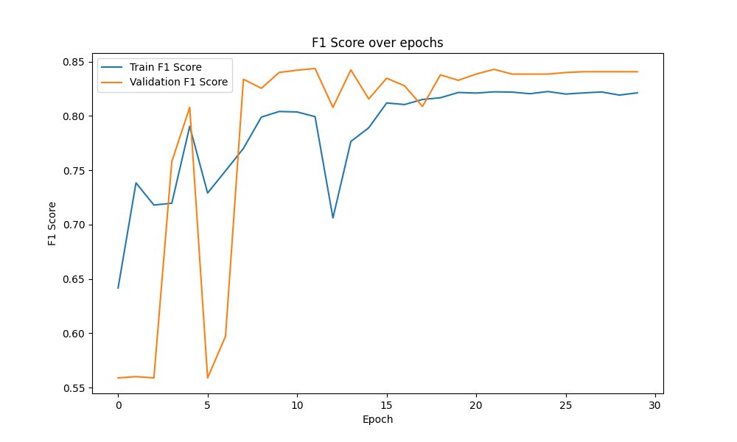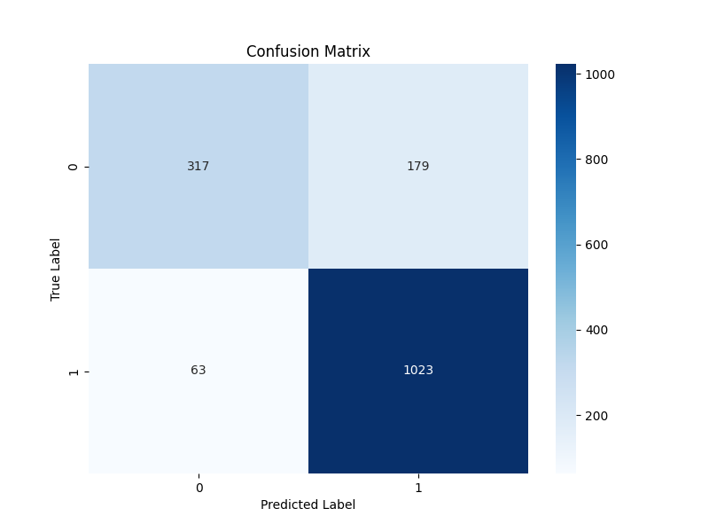

1. **MobileNetV2**

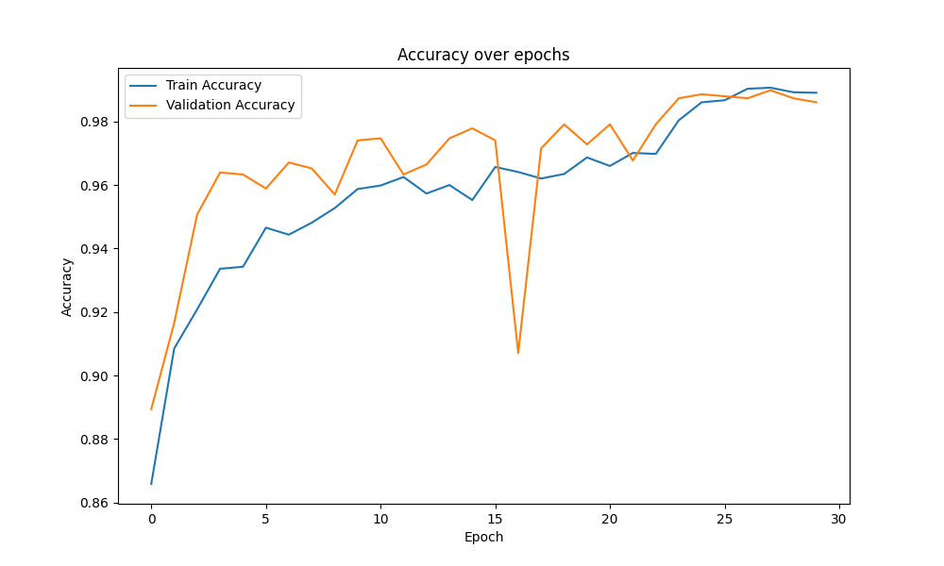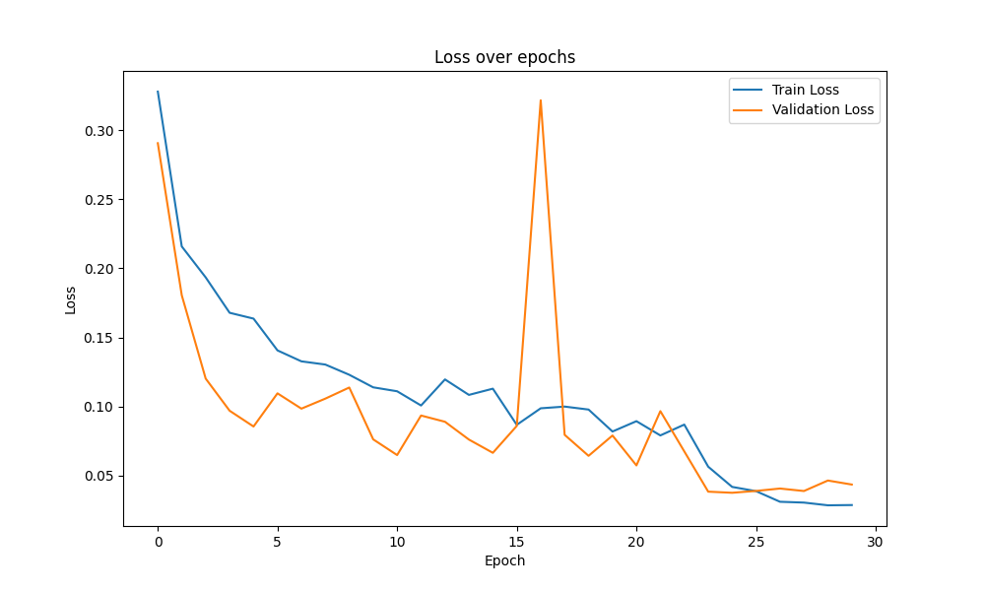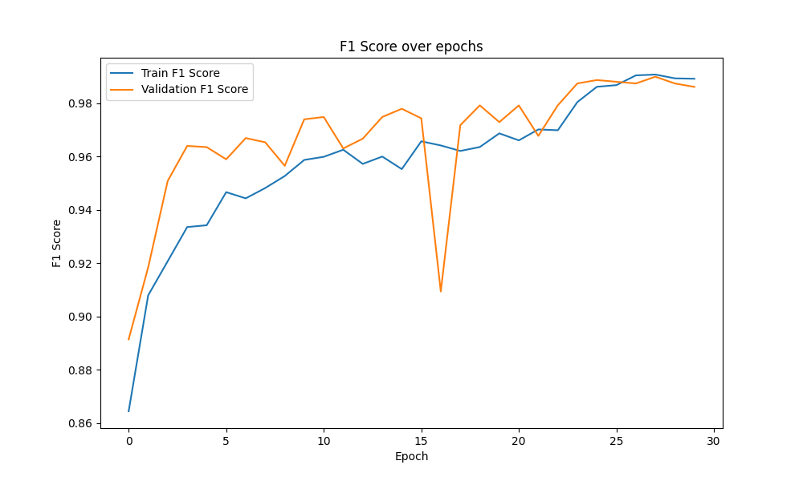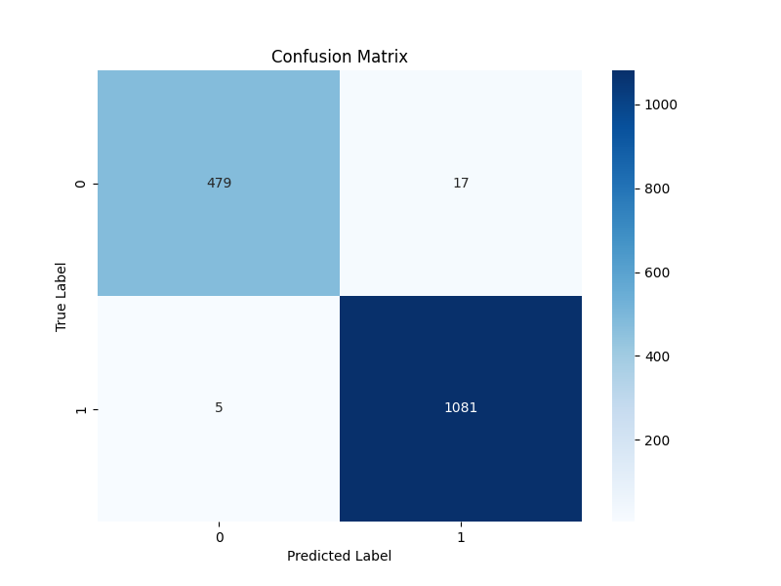

**Hyperparameter Optimization**

**Parameters Explored:**

* **Learning Rates:** [0.1, 0.01, 0.001].
* **Batch Sizes:** [16, 32, 64].

**Results:**

* Best learning rate: **0.001**.
* Best batch size: **16**.

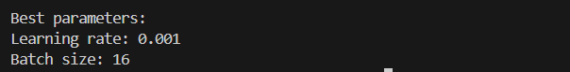

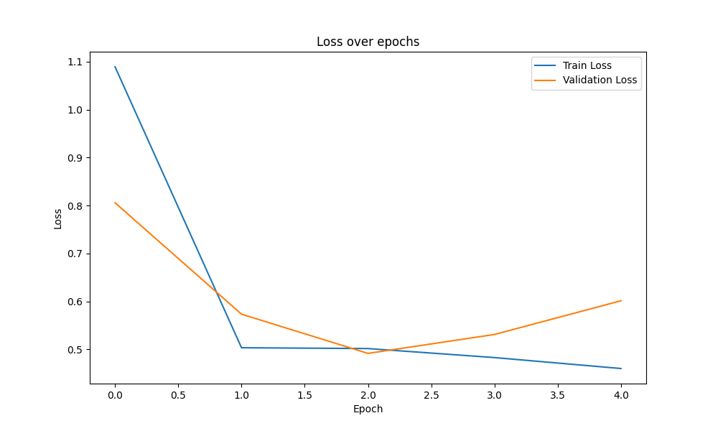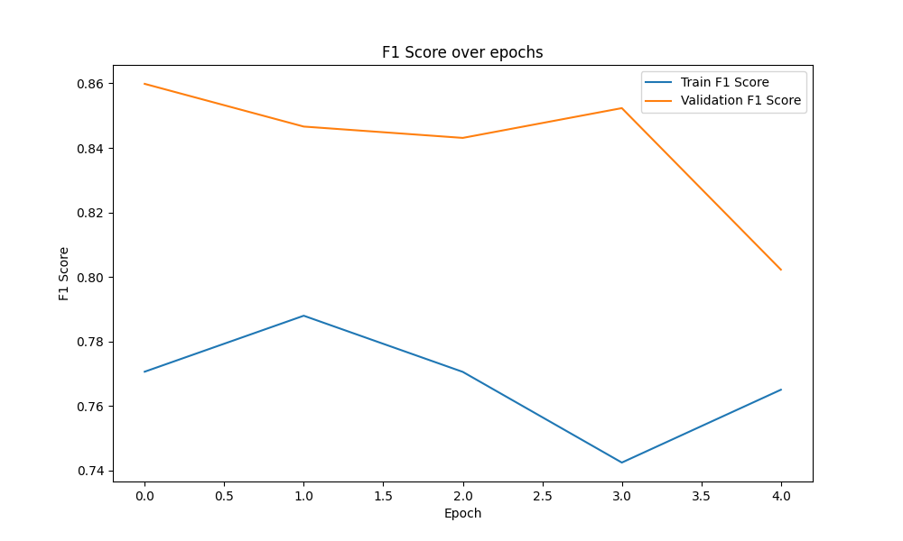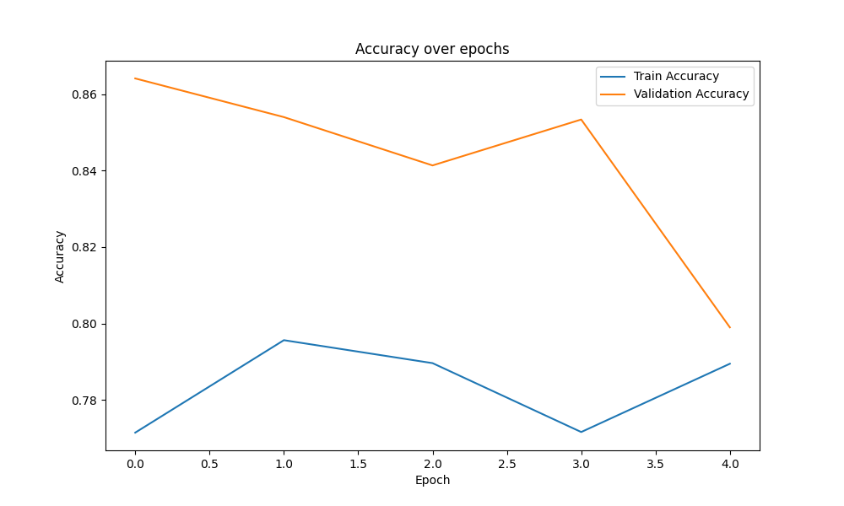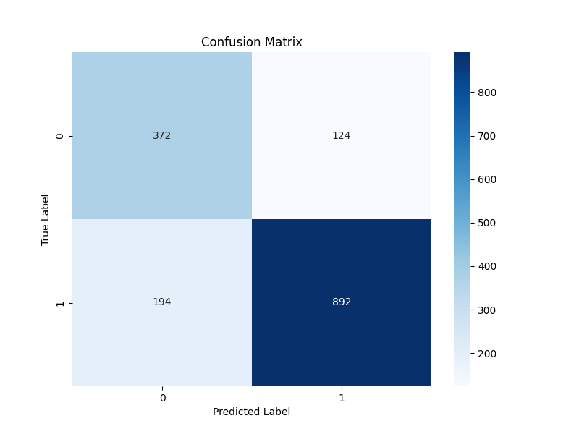

**Code :**

import torch

import torch.nn as nn

import torch.optim as optim

from torch.utils.data import Dataset, DataLoader

from torchvision import transforms, models

import os

from PIL import Image

import numpy as np

from sklearn.metrics import accuracy_score, f1_score, roc_auc_score, confusion_matrix

from sklearn.model_selection import train_test_split

import matplotlib.pyplot as plt

import seaborn as sns

from torch.optim.lr_scheduler import ReduceLROnPlateau

class BreastCancerDataset(Dataset):

    def __init__(self, image_paths, labels, transform=None):

        self.image_paths = image_paths

        self.labels = labels

        self.transform = transform

    def __len__(self):

        return len(self.image_paths)

    def __getitem__(self, idx):

        image = Image.open(self.image_paths[idx]).convert('RGB')

        if self.transform:

            image = self.transform(image)

        label = self.labels[idx]

        return image, label

class BasicCNN(nn.Module):

    def __init__(self):

        super(BasicCNN, self).__init__()

        self.conv_layers = nn.Sequential(

            # First Conv Block

            nn.Conv2d(3, 32, kernel_size=3, padding=1),

            nn.ReLU(),

            nn.BatchNorm2d(32),

            nn.MaxPool2d(2),

            # Second Conv Block

            nn.Conv2d(32, 64, kernel_size=3, padding=1),

            nn.ReLU(),

            nn.BatchNorm2d(64),

            nn.MaxPool2d(2),

            # Third Conv Block

            nn.Conv2d(64, 128, kernel_size=3, padding=1),

            nn.ReLU(),

            nn.BatchNorm2d(128),

            nn.MaxPool2d(2),

            # Fourth Conv Block

            nn.Conv2d(128, 256, kernel_size=3, padding=1),

            nn.ReLU(),

            nn.BatchNorm2d(256),

            nn.MaxPool2d(2)

        )

        self.classifier = nn.Sequential(

            nn.Flatten(),

            nn.Linear(256 * 14 * 14, 512),

            nn.ReLU(),

            nn.Dropout(0.5),

            nn.Linear(512, 2)

        )

    def forward(self, x):

        x = self.conv_layers(x)

        x = self.classifier(x)

        return x

def get_pretrained_model(model_name, num_classes=2):

    if model_name == 'resnet50':

        model = models.resnet50(pretrained=True)

        num_features = model.fc.in_features

        model.fc = nn.Linear(num_features, num_classes)

    elif model_name == 'vgg16':

        model = models.vgg16(pretrained=True)

        num_features = model.classifier[6].in_features

        model.classifier[6] = nn.Linear(num_features, num_classes)

    elif model_name == 'mobilenet':

        model = models.mobilenet_v2(pretrained=True)

        num_features = model.classifier[1].in_features

        model.classifier[1] = nn.Linear(num_features, num_classes)

    return model

class ModelTrainer:

    def __init__(self, model, device, criterion, optimizer, scheduler=None):

        self.model = model

        self.device = device

        self.criterion = criterion

        self.optimizer = optimizer

        self.scheduler = scheduler

        self.best_val_score = 0

    def train_epoch(self, train_loader):

        self.model.train()

        running_loss = 0.0

        predictions = []

        true_labels = []

        for inputs, labels in train_loader:

            inputs, labels = inputs.to(self.device), labels.to(self.device)

            self.optimizer.zero_grad()

            outputs = self.model(inputs)

            loss = self.criterion(outputs, labels)

            loss.backward()

            self.optimizer.step()

            running_loss += loss.item()

            _, preds = torch.max(outputs, 1)

            predictions.extend(preds.cpu().numpy())

            true_labels.extend(labels.cpu().numpy())

        epoch_loss = running_loss / len(train_loader)

        epoch_acc = accuracy_score(true_labels, predictions)

        epoch_f1 = f1_score(true_labels, predictions, average='weighted')

        return epoch_loss, epoch_acc, epoch_f1

    def evaluate(self, val_loader):

        self.model.eval()

        predictions = []

        true_labels = []

        val_loss = 0.0

        with torch.no_grad():

            for inputs, labels in val_loader:

                inputs, labels = inputs.to(self.device), labels.to(self.device)

                outputs = self.model(inputs)

                loss = self.criterion(outputs, labels)

                val_loss += loss.item()

                _, preds = torch.max(outputs, 1)

                predictions.extend(preds.cpu().numpy())

                true_labels.extend(labels.cpu().numpy())

        val_loss = val_loss / len(val_loader)

        val_acc = accuracy_score(true_labels, predictions)

        val_f1 = f1_score(true_labels, predictions, average='weighted')

        val_auc = roc_auc_score(true_labels, predictions)

        return val_loss, val_acc, val_f1, val_auc, predictions, true_labels

def plot_metrics(train_metrics, val_metrics, metric_name):

    plt.figure(figsize=(10, 6))

    plt.plot(train_metrics, label=f'Train {metric_name}')

    plt.plot(val_metrics, label=f'Validation {metric_name}')

    plt.title(f'{metric_name} over epochs')

    plt.xlabel('Epoch')

    plt.ylabel(metric_name)

    plt.legend()

    plt.show()

def plot_confusion_matrix(true_labels, predictions):

    cm = confusion_matrix(true_labels, predictions)

    plt.figure(figsize=(8, 6))

    sns.heatmap(cm, annot=True, fmt='d', cmap='Blues')

    plt.title('Confusion Matrix')

    plt.ylabel('True Label')

    plt.xlabel('Predicted Label')

    plt.show()

def train_and_evaluate(data_dir, model_type='basic_cnn', num_epochs=30):

    # Set device

    device = torch.device("cuda" if torch.cuda.is_available() else "cpu")

    print(f"Using device: {device}")

    # Data preparation

    transform_train = transforms.Compose([

        transforms.Resize((224, 224)),

        transforms.RandomHorizontalFlip(),

        transforms.RandomRotation(10),

        transforms.RandomAffine(degrees=0, translate=(0.1, 0.1)),

        transforms.ColorJitter(brightness=0.2, contrast=0.2),

        transforms.ToTensor(),

        transforms.Normalize(mean=[0.485, 0.456, 0.406], std=[0.229, 0.224, 0.225])

    ])

    transform_val = transforms.Compose([

        transforms.Resize((224, 224)),

        transforms.ToTensor(),

        transforms.Normalize(mean=[0.485, 0.456, 0.406], std=[0.229, 0.224, 0.225])

    ])

    # Prepare data

    image_paths = []

    labels = []

    for image_name in os.listdir(data_dir):

        if image_name.endswith('.png'):

            parts = image_name.split('_')

            tumor_class = parts[1]

            image_paths.append(os.path.join(data_dir, image_name))

            labels.append(1 if tumor_class == 'M' else 0)

    # Split data

    train_paths, val_paths, train_labels, val_labels = train_test_split(

        image_paths, labels, test_size=0.2, random_state=42, stratify=labels

    )

    # Create datasets

    train_dataset = BreastCancerDataset(train_paths, train_labels, transform_train)

    val_dataset = BreastCancerDataset(val_paths, val_labels, transform_val)

    # Create dataloaders

    train_loader = DataLoader(train_dataset, batch_size=32, shuffle=True)

    val_loader = DataLoader(val_dataset, batch_size=32)

    # Model selection

    if model_type == 'basic_cnn':

        model = BasicCNN()

    else:

        model = get_pretrained_model(model_type)

    model = model.to(device)

    # Training setup

    criterion = nn.CrossEntropyLoss()

    optimizer = optim.Adam(model.parameters(), lr=0.001)

    scheduler = ReduceLROnPlateau(optimizer, mode='max', factor=0.1, patience=3)

    # Initialize trainer

    trainer = ModelTrainer(model, device, criterion, optimizer, scheduler)

    # Training history

    train_losses, train_accs, train_f1s = [], [], []

    val_losses, val_accs, val_f1s, val_aucs = [], [], [], []

    # Training loop

    for epoch in range(num_epochs):

        # Train

        train_loss, train_acc, train_f1 = trainer.train_epoch(train_loader)

        # Evaluate

        val_loss, val_acc, val_f1, val_auc, predictions, true_labels = trainer.evaluate(val_loader)

        # Update learning rate

        if trainer.scheduler:

            trainer.scheduler.step(val_acc)

        # Save metrics

        train_losses.append(train_loss)

        train_accs.append(train_acc)

        train_f1s.append(train_f1)

        val_losses.append(val_loss)

        val_accs.append(val_acc)

        val_f1s.append(val_f1)

        val_aucs.append(val_auc)

        print(f'Epoch {epoch+1}/{num_epochs}:')

        print(f'Train Loss: {train_loss:.4f}, Train Acc: {train_acc:.4f}, Train F1: {train_f1:.4f}')

        print(f'Val Loss: {val_loss:.4f}, Val Acc: {val_acc:.4f}, Val F1: {val_f1:.4f}, Val AUC: {val_auc:.4f}')

        # Save best model

        if val_acc > trainer.best_val_score:

            trainer.best_val_score = val_acc

            torch.save(model.state_dict(), f'best_model_{model_type}.pth')

    # Plot metrics

    plot_metrics(train_losses, val_losses, 'Loss')

    plot_metrics(train_accs, val_accs, 'Accuracy')

    plot_metrics(train_f1s, val_f1s, 'F1 Score')

    plot_confusion_matrix(true_labels, predictions)

    return model, trainer.best_val_score

def hyperparameter_optimization(data_dir, model_type='basic_cnn'):

    learning_rates = [0.1, 0.01, 0.001]

    batch_sizes = [16, 32, 64]

    best_params = {'lr': None, 'batch_size': None}

    best_score = 0

    for lr in learning_rates:

        for batch_size in batch_sizes:

            print(f"\nTrying lr={lr}, batch_size={batch_size}")

            _, val_score = train_and_evaluate(

                data_dir,

                model_type=model_type,

                num_epochs=5  # Reduced epochs for faster optimization

            )

            if val_score > best_score:

                best_score = val_score

                best_params['lr'] = lr

                best_params['batch_size'] = batch_size

    print("\nBest parameters:")

    print(f"Learning rate: {best_params['lr']}")

    print(f"Batch size: {best_params['batch_size']}")

    return best_params

if __name__ == "__main__":

    data_dir = "../datasets/all_images"

    # Train and evaluate basic CNN

    print("Training Basic CNN...")

    train_and_evaluate(data_dir, model_type='basic_cnn')

    # Train and evaluate pretrained models

    for model_type in ['resnet50', 'vgg16', 'mobilenet']:

        print(f"\nTraining {model_type}...")

        train_and_evaluate(data_dir, model_type=model_type)

    # Perform hyperparameter optimization

    print("\nOptimizing hyperparameters...")

    best_params = hyperparameter_optimization(data_dir)